모바일프로그래밍 과제05 컴퓨터소프트웨어공학과 2-YA 20202296 전채린

예제4-16

[소스코드]

<?xml version="1.0" encoding="utf-8"?>  
<LinearLayout xmlns:android="http://schemas.android.com/apk/res/android"  
 xmlns:app="http://schemas.android.com/apk/res-auto"  
 xmlns:tools="http://schemas.android.com/tools"  
 android:layout_width="match_parent"  
 android:layout_height="match_parent"  
 android:orientation="vertical"  
 tools:context=".MainActivity">  
  
 /* 01 텍스트뷰  
 예제4-16 글자 관련 속성의 XML 코드 */  
  
 <TextView  
 android:layout_width="match_parent"  
 android:layout_height="wrap_content"  
 android:textSize="30sp"  
 android:text="textSize 속성" />  
 <TextView  
 android:layout_width="match_parent"  
 android:layout_height="wrap_content"  
 android:textSize="30dp"  
 android:textColor="#00FF00"  
 android:text="textColor 속성" />  
 <TextView  
 android:layout_width="match_parent"  
 android:layout_height="wrap_content"  
 android:textSize="30dp"  
 android:textStyle="bold|italic"  
 android:text="textStyle 속성" />  
 <TextView  
 android:layout_width="match_parent"  
 android:layout_height="wrap_content"  
 android:textSize="30dp"  
 android:typeface="serif"  
 android:text="textface 속성" />  
 <TextView  
 android:layout_width="match_parent"  
 android:layout_height="wrap_content"  
 android:textSize="30dp"  
 android:singleLine="true"  
 android:text="singleLine 속성 singleLine 속성 singleLine 속성" />  
</LinearLayout>

[실행결과]

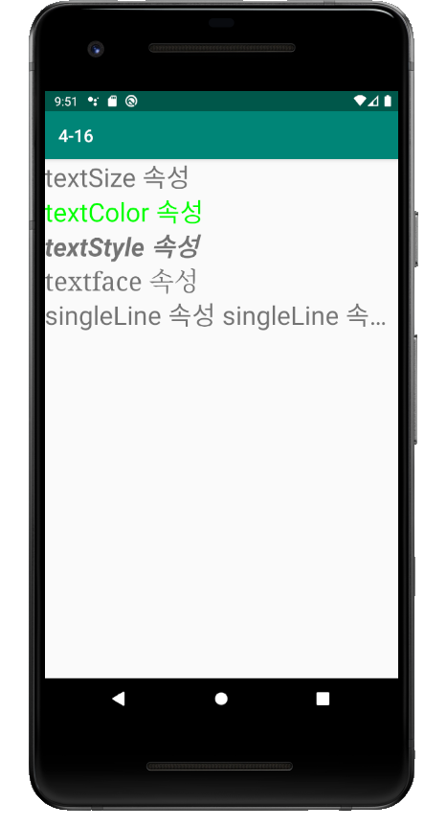

예제4-17

[소스코드]

<?xml version="1.0" encoding="utf-8"?>  
<LinearLayout xmlns:android="http://schemas.android.com/apk/res/android"  
 xmlns:app="http://schemas.android.com/apk/res-auto"  
 xmlns:tools="http://schemas.android.com/tools"  
 android:layout_width="match_parent"  
 android:layout_height="match_parent"  
 android:orientation="vertical"  
 tools:context=".MainActivity">  
  
 /* 01 텍스트뷰  
 예제4-17 텍스트뷰가 3개 있는 activity_main.xml */  
  
 <TextView  
 android:layout_width="match_parent"  
 android:layout_height="wrap_content"  
 android:text="TextView 연습 1"  
 android:id="@+id/textView1"/>  
 <TextView  
 android:layout_width="match_parent"  
 android:layout_height="wrap_content"  
 android:text="TextView 연습 2"  
 android:id="@+id/textView2"/>  
 <TextView  
 android:layout_width="match_parent"  
 android:layout_height="wrap_content"  
 android:text="TextView 연습 3"  
 android:id="@+id/textView3"/>  
  
</LinearLayout>

[실행결과]

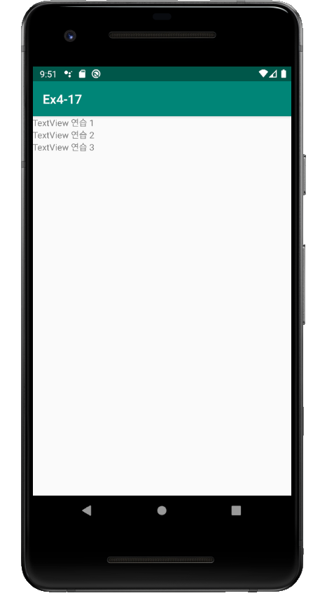

예제4-18

[소스코드]

/* 02 Kotlin 코드로 XML 속성 설정  
* 예제4-18 텍스트 속성을 변경하는 Kotlin 코드 */  
package aca.dongyang.ex4_17  
  
import android.graphics.Color  
import android.graphics.Typeface  
import androidx.appcompat.app.AppCompatActivity  
import android.os.Bundle  
import kotlinx.android.synthetic.main.activity_main.*  
  
class MainActivity : AppCompatActivity() {  
  
 override fun onCreate(savedInstanceState: Bundle?) {  
 super.onCreate(savedInstanceState)  
 setContentView(R.layout.*activity_main*)  
  
 textView1.setText("안녕하세요..")  
 textView1.setTextColor(Color.*RED*)  
 textView2.setTextSize(30.0f)  
 textView2.setTypeface(Typeface.*SERIF*)  
 textView3.setText("가나다라마바사아자차카타파하가나다라마바사아자차카타파하")  
 textView3.setSingleLine()  
 }  
}

[실행결과]

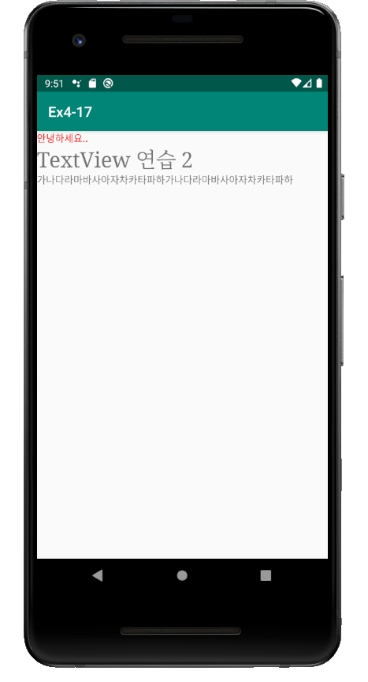

직접 풀어보기 4-2

[소스코드]

<?xml version="1.0" encoding="utf-8"?>  
<LinearLayout xmlns:android="http://schemas.android.com/apk/res/android"  
 xmlns:app="http://schemas.android.com/apk/res-auto"  
 xmlns:tools="http://schemas.android.com/tools"  
 android:layout_width="match_parent"  
 android:layout_height="match_parent"  
 android:orientation="vertical"  
 android:padding="30dp"  
 tools:context=".MainActivity">  
  
 /* 02 View 클래스의 XML 속성  
 직접 풀어보기4-2  
 다음과 같은 화면을 XML로 코딩하라.  
 버튼, 텍스트뷰, 에디트텍스트, 버튼을 차례로 지정하고 앞에서 배운 다양한 속성을 사용한다. */  
  
 <Button  
 android:layout_width="match_parent"  
 android:layout_height="wrap_content"  
 android:layout_margin="20dp"  
 android:text="버튼 1" />  
 <TextView  
 android:layout_width="match_parent"  
 android:layout_height="wrap_content"  
 android:layout_margin="20dp"  
 android:text="여긴 텍스트뷰입니다." />  
 <EditText  
 android:layout_width="match_parent"  
 android:layout_height="wrap_content"  
 android:layout_margin="20dp" />  
 <Button  
 android:layout_width="wrap_content"  
 android:layout_height="match_parent"  
 android:layout_margin="20dp"  
 android:text="버튼 2" />  
  
</LinearLayout>

[실행결과]

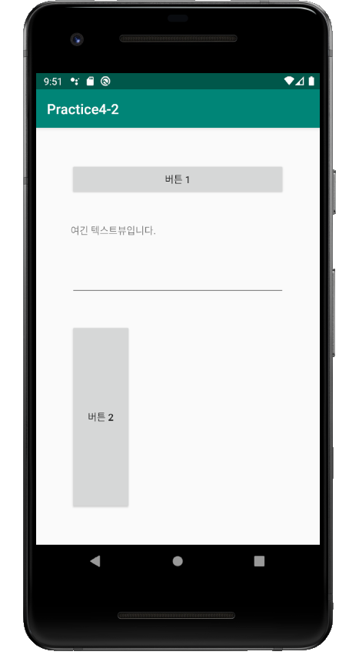

실습 4-1

[소스코드]

<?xml version="1.0" encoding="utf-8"?>  
<LinearLayout xmlns:android="http://schemas.android.com/apk/res/android"  
 xmlns:app="http://schemas.android.com/apk/res-auto"  
 xmlns:tools="http://schemas.android.com/tools"  
 android:layout_width="match_parent"  
 android:layout_height="match_parent"  
 android:orientation="vertical"  
 tools:context=".MainActivity">  
  
 /* 03 버튼과 에디트텍스트  
 예제4-19 activity_main.xml */  
  
 <EditText  
 android:id="@+id/Edit1"  
 android:layout_width="wrap_content"  
 android:layout_height="wrap_content"  
 android:layout_margin="10dp"  
 android:text="숫자1" />  
 <EditText  
 android:id="@+id/Edit2"  
 android:layout_width="wrap_content"  
 android:layout_height="wrap_content"  
 android:layout_margin="10dp"  
 android:text="숫자2" />  
 <Button  
 android:id="@+id/BtnAdd"  
 android:layout_width="match_parent"  
 android:layout_height="wrap_content"  
 android:layout_margin="10dp"  
 android:text="더하기" />  
 <Button  
 android:id="@+id/BtnSub"  
 android:layout_width="match_parent"  
 android:layout_height="wrap_content"  
 android:layout_margin="10dp"  
 android:text="빼기" />  
 <Button  
 android:id="@+id/BtnMul"  
 android:layout_width="match_parent"  
 android:layout_height="wrap_content"  
 android:layout_margin="10dp"  
 android:text="곱하기" />  
 <Button  
 android:id="@+id/BtnDiv"  
 android:layout_width="match_parent"  
 android:layout_height="wrap_content"  
 android:layout_margin="10dp"  
 android:text="나누기" />  
 <TextView  
 android:id="@+id/TextResult"  
 android:layout_width="wrap_content"  
 android:layout_height="wrap_content"  
 android:textSize="30dp"  
 android:textColor="#FF0000"  
 android:layout_margin="10dp"  
 android:text="계산 결과 : " />  
</LinearLayout>

[실행결과]

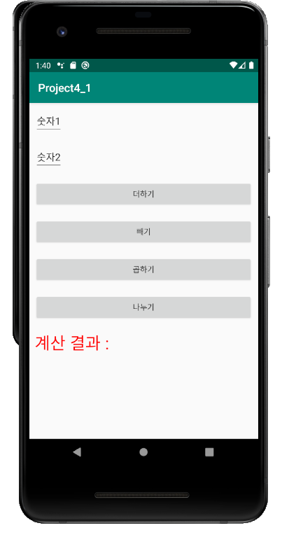

실습 4-1

[소스코드]

/* 03 버튼과 에디트텍스트  
 예제4-20 Kotlin 코드 */  
package aca.dongyang.project4_1  
  
import androidx.appcompat.app.AppCompatActivity  
import android.os.Bundle  
import kotlinx.android.synthetic.main.activity_main.*  
  
class MainActivity : AppCompatActivity() {  
 lateinit var num1 : String  
 lateinit var num2 : String  
 var result : Int? = null  
  
 override fun onCreate(savedInstanceState: Bundle?) {  
 super.onCreate(savedInstanceState)  
 setContentView(R.layout.*activity_main*)  
  
 // setTouchListener  
 BtnAdd.setOnTouchListener **{** view, motionEvent **->** num1 = Edit1.*text*.toString()  
 num2 = Edit2.*text*.toString()  
 result = Integer.parseInt(num1) + Integer.parseInt(num2)  
 TextResult.*text* = "계산 결과 : " + result  
 false  
 **}** BtnSub.setOnTouchListener **{** view, motionEvent **->** num1 = Edit1.*text*.toString()  
 num2 = Edit2.*text*.toString()  
 result = Integer.parseInt(num1) - Integer.parseInt(num2)  
 TextResult.*text* = "계산 결과 : " + result  
 false  
 **}** BtnMul.setOnTouchListener **{** view, motionEvent **->** num1 = Edit1.*text*.toString()  
 num2 = Edit2.*text*.toString()  
 result = Integer.parseInt(num1) * Integer.parseInt(num2)  
 TextResult.*text* = "계산 결과 : " + result  
 false  
 **}** BtnDiv.setOnTouchListener **{** view, motionEvent **->** num1 = Edit1.*text*.toString()  
 num2 = Edit2.*text*.toString()  
 result = Integer.parseInt(num1) / Integer.parseInt(num2)  
 TextResult.*text* = "계산 결과 : " + result  
 false  
 **}** // setClickListener  
 BtnAdd.setOnClickListener **{** num1 = Edit1.*text*.toString()  
 num2 = Edit2.*text*.toString()  
 result = Integer.parseInt(num1) + num2.*toInt*()  
 TextResult.*text* = "계산 결과 : " + result  
 **}** BtnSub.setOnClickListener **{** num1 = Edit1.*text*.toString()  
 num2 = Edit2.*text*.toString()  
 result = Integer.parseInt(num1) - num2.*toInt*()  
 TextResult.*text* = "계산 결과 : " + result  
 **}** BtnMul.setOnClickListener **{** num1 = Edit1.*text*.toString()  
 num2 = Edit2.*text*.toString()  
 result = Integer.parseInt(num1) * num2.*toInt*()  
 TextResult.*text* = "계산 결과 : " + result  
 **}** BtnDiv.setOnClickListener **{** num1 = Edit1.*text*.toString()  
 num2 = Edit2.*text*.toString()  
 result = Integer.parseInt(num1) / num2.*toInt*()  
 TextResult.*text* = "계산 결과 : " + result  
 **}** }  
}

[실행결과]

더하기/빼기

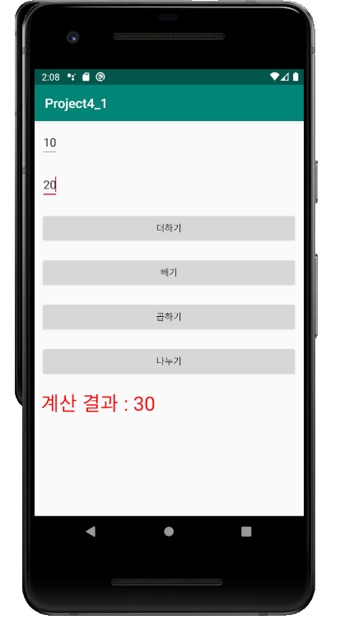 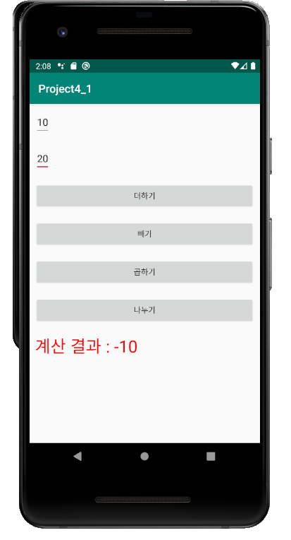

곱하기/나누기

